Faculty of Computing and Technology

University of Kelaniya

Sri Lanka



CTEC 22043

**Object Oriented Programming**

Day LW 3 - Defining Classes

CT/2021/054 – Y. H. K. Navanjana

1. Code

* Output

1. Code

* Output

1. Code

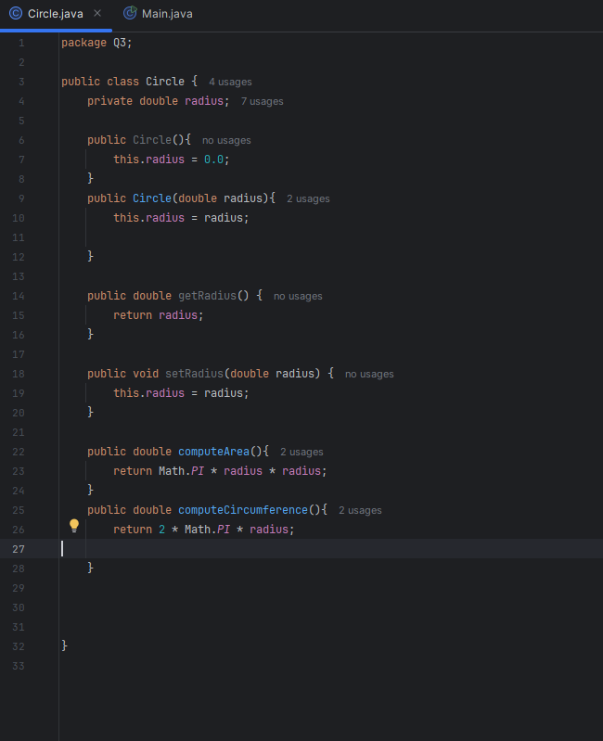

* Output

1. Code

* Output

1. Code

* Output

